V.3 Acceleration Processes
(Consequences of Transport Effects)
Basics
In the following the fundamental transport equation will be the basis of acceleration processes. Transport and acceleration are intimately linked.
$\begin{aligned}\frac{¶f}{¶t}+\vec{v}Ñf+Q(\vec{v}x{\vec{B}}_{o})\frac{¶f}{¶\vec{p}}=á\frac{¶}{¶\vec{p}}(\underline{\underline{D}}\frac{¶f}{¶\vec{p}})⟩ \\ \text{Convection} \text{Drift} \text{Momentum}\text{Diffusion}\end{aligned}$ V.3_1

The results from the preceding discussion (i.e. that particle distributions are assimilated into a moving rest frame) is the reason for one of the fundamental acceleration processes, driven by the interplay of scattering and a substantial bulk flow between 2 media:
- diffusive or 1st order Fermi acceleration
In the equation it is the Convection term along with the pitch-angle scattering that do the trick.
The second process also involves bulk flow, magnetic fields (and thus the induced electric fields) to accelerate particles (in a deterministic manner along the trajectories in E and B fields).
- shock drift acceleration
In the equation it is the Drift term that is the driver.
Finally, we will see that electromagnetic fluctuations, which move at random in the plasma rest frame, just by means of scattering, will lead to a stochastic energy gain, i.e. acceleration.
- 2nd order Fermi acceleration
This is based on the Diffusion term on the right hand side. However, it is the term of the p component, if we represent p = (p, µ).
Ultimately we will see that in all these cases electric fields play a fundamental role, at least on the micro-level, although sometimes hidden by the description of the process. Because electric fields in nature are generally produced by induction due to relative motion w.r.t. to a magnetic field, these will be mostly electric fields perpendicular to B. I will consider acceleration in E||B as a special case (very simple case) of the second example. In such cases particles gain the total energy by falling through an electric potential, which is limited by the gyroradii in each step of drift acceleration. Generally, we need to add one more process, magnetic pumping (based on dB/dt), but this can also be interpreted as an induced E-field.
Because in many cases in astrophysical plasmas also v_{bulk} >> v_{A}, acceleration based on v_{bulk} (1st order Fermi) is often more important than that based on turbulent waves with v_{A} (2nd order Fermi), which in addition scales with the square of the speed. This is generally true for all energetic particle populations in the solar wind. Here also the energy density is smaller than that of the solar wind.

Interpretation of Physical Terms of the Transport Equation
$\frac{¶f}{¶t}+\vec{v}Ñf+Q(\vec{v}x{\vec{B}}_{o})\frac{¶f}{¶\vec{p}}=\frac{¶}{¶m}[(1−m^{2})D_{m}\frac{¶f}{¶m}]+\frac{¶}{¶p}(D_{{}_{p}}\frac{¶f}{¶p})$ (V3_2)
The distribution function f can be inhomogeneous, i.e. have a gradient, and we allow moving frames. Scattering is treated as diffusion in p and µ. Let us make the assumption that momentum diffusion, i.e. diffusion that changes the total energy of the particles is inefficient. So we drop this term, but we keep pitch angle diffusion.
Let us further use, where convenient and if not addressed otherwise f_{o}, i.e. the isotropic main part of f. If needed, we will add a small anisotropic part, i.e. f will always be nearly isotropic (diffusion approximation). We can define the one dimensional phase space F(p) density of f_{o} as:
F(p) = 4πp²f_{o} with n = ∫F(p)dp
We recall that we derived (V3_2) originally from conservation of particles in phase space:
$\frac{¶F}{¶t}+Ñ{\vec{S}}_{x}+\frac{¶}{¶p}{\vec{S}}_{p}=0$ (j = ∫S_{x}dp) (V3_2a)
where S_{x} is the streaming (phase space flux) in configuration space and S_{p} the streaming in momentum (p) space. The change of the flux in momentum space thus must be related to work done on particles between p and p+dp. We know that the solar wind does work on a particle population according to:
$\begin{aligned}\text{work}={\vec{V}}_{\text{sw}}⋅ÑP \text{where}P=\frac{1}{3}\int{\text{pvF}(p)\text{dp}} \\ \text{Note}\text{: }1/3\text{comes}\text{from isotropic}F\text{, }3\text{degrees of freedom}\end{aligned}$
Hence:
$S_{p}=V⋅Ñ(\frac{1}{3}\text{pF}(p)) \text{where}V\text{any bulk flow}$ (V.3_3)
Now S_{x} comes from (1) convection, (2) drift, and (3) diffusion.
- Assume f isotropic in frame flowing with |V| << v. Then we can set in the observer frame:
f = f_{o}(p) – V(p/v)∂f_{o}/∂p (linear expansion)
Then:
$\begin{aligned}j=\text{nV}=\int{\frac{4p}{3}p^{2}\text{vf}(p)\text{dp}»}−V\int{\frac{4p}{3}p^{3}\frac{¶f_{o}}{¶p}\text{dp} } \\ \text{or}\text{: }S_{x(\text{Convection})}=−V\frac{4p}{3}p^{3}\frac{¶f_{o}}{¶p}\end{aligned}$ (V.3_4)
This is in essence the Compton-Getting effect that we already discussed.
(2) Drifts are produced by inhomogeneous magnetic fields and inhomogeneous distributions perpendicular to magnetic fields. I.e. we have to look at motion solely perpendicular to B. This term is independent of any scattering. In principle, we only need to keep the 2nd and 3rd term on the left-hand side of (V.3_2). Still this is a relatively complex series of vector and matrix operation. Let a plausibility argument suffice. We have encountered gradient drift in our discussion after the Compton-Getting effect about remaining anisotropies. We arrived heuristically at a relation:
$\begin{aligned}j_{D}=r_{\text{ci}}vÑn=\frac{{\text{mv}}^{2}}{\text{QB}}Ñn \\ \text{with similar arguments about an isotropic distribution:} \\ S_{\hat{}=\frac{\text{pv}}{3Q}\frac{{\vec{B}}_{o}}{B_{o}^{2}}\text{´Ñ}F}\end{aligned}$ (V.3_5)
(3) Finally, diffusion in configuration space is connected to pitch angle diffusion. We take the resulting net motion as ||B. This is true as long as scattering from field line to field line or a tangling of field lines (spaghetti), as lately assumed for interplanetary field, are unimportant. I.e. the dominant term is:
$\begin{aligned}v_{z}\frac{¶f}{¶z}=\frac{¶}{¶m}[(1−m^{2})D_{m}\frac{¶f}{¶m}] \\ \text{Now we use a deviation from the isotropic distribution}f_{o} \\ f=f_{o}+g \text{where} \text{still}\text{: } \\ \end{aligned}\begin{aligned}\int{}\end{aligned}ò\text{gd}m=0$ (V.3_6)
We compute the flux j by integrating over p space, noting that this is only an integral over µ, where v_{z} = vµ. Integrating over the first equation (V.3_6) we get:
$v\frac{m^{2}}{2}\frac{¶f_{o}}{¶z}=(1−m^{2})D_{m}\frac{¶g}{¶m}+A$ (V.3_7)
g drops out of the integration on the left hand side with integration by parts and ∫gdµ = 0. On the right hand side the term with f_{o} is 0, because f_{o} is isotropic and not subject to diffusion. Evaluating (V.3_7) at µ±1 yields: A = v/2∂f_{o}/∂z. Now we get:
$\begin{aligned}\frac{¶g}{\text{¶m}}=−\frac{v}{2D_{m}}\frac{¶f_{o}}{¶z} \text{after integration:} \\ g\text{ = }−\frac{v}{2}\frac{¶f_{o}}{¶z}\int_{0}^{m}{\frac{dm'}{D_{m}}}+C\end{aligned}$
Now we get S|| = 4πp²v∫µgdµ. After integration by parts for µ from –1 to +1:
$\begin{aligned}S_{||}=−4{pp}^{2}\frac{v^{2}}{8}\frac{¶f_{o}}{¶z}\int_{−1}^{1}{\frac{(1−m^{2})}{D_{m}}dm}=−4{pp}^{2}D_{||}\frac{¶f_{o}}{¶z} \\ \text{where}\text{: }D_{||}=\frac{v^{2}}{8}\int_{−1}^{1}{\frac{(1−m^{2})}{D_{m}}dm}\end{aligned}$ (V.3_8)
Collecting all terms into (V.3_2) we arrive at:
$\begin{aligned}\frac{¶F}{¶t}+Ñ[−V\frac{4p}{3}p^{3}\frac{¶f_{o}}{¶p}+\frac{\text{pv}}{3Q}\frac{{\vec{B}}_{o}}{B_{o}^{2}}\text{´Ñ}F+4{pp}^{2}D_{m}{\hat{e}}_{z}\frac{¶f_{o}}{¶z}]+\frac{¶}{¶p}[V⋅Ñ(\frac{1}{3}\text{pF})]=0 \\ \text{with}4{pp}^{2}f_{o}=F\text{, }i\text{.}e\text{.}\text{divinding}\text{by}4{pp}^{2}: \\ \frac{¶f_{o}}{¶t}+Ñ[−\frac{V}{3}p\frac{¶f_{o}}{¶p}+\frac{\text{pv}}{3Q}\frac{{\vec{B}}_{o}}{B_{o}^{2}}\text{´Ñ}f_{o}+D_{m}{\hat{e}}_{z}\frac{¶f_{o}}{¶z}]+V⋅Ñ[\frac{1}{3p^{2}}\frac{¶}{¶p}(p^{3}f_{o})]=0\end{aligned}$ (V.3_9)
Compton-Getting Drift Diffusion Flux in p-space
The Compton-Getting and the p-space term can be combined differently (noting that also V may vary in space):
$\begin{aligned}Ñ[−\frac{V}{3}p\frac{¶f_{o}}{¶p}]\text{=-}\frac{ÑV}{3}p\frac{¶f_{o}}{¶p}−\frac{V}{3}Ñ(p\frac{¶f_{o}}{¶p}) \\ + \text{=-}\frac{ÑV}{3}p\frac{¶f_{o}}{¶p}+V⋅{Ñf}_{o} \\ V⋅Ñ[\frac{1}{3p^{2}}\frac{¶}{¶p}(p^{3}f_{o})]=\frac{V}{3}⋅Ñ[\frac{1}{p^{2}}(p^{3}\frac{¶f_{o}}{¶p}+3p^{2}f_{o})]\end{aligned}$
In addition, the Drift Term can be rearranged using: $Ñ(\vec{A}´\vec{B})=\vec{B}(\text{Ñ´ \{}\vec{A})−\vec{A}(\text{Ñ´ \{}\vec{B})$
$\begin{aligned}\frac{\text{pv}}{3Q}\frac{{\vec{B}}_{o}}{B_{o}^{2}}\text{´Ñ}f_{o}=(\frac{\text{pv}}{3Q}\text{Ñ´}\frac{{\vec{B}}_{o}}{B_{o}^{2}}){Ñf}_{o}=V_{D}{Ñf}_{o} \\ \text{where}\text{the}2\text{nd}\text{term}=0\text{, }\text{because}\text{Ñ´Ñ}A=0\text{.}\end{aligned}$
This leads to:
$\frac{¶f_{o}}{¶t}+{VÑf}_{o}+V_{D}{Ñf}_{o}+Ñ(D_{m}{Ñf}_{o})−\frac{1}{3}ÑV⋅p\frac{¶f_{o}}{¶p}=0$ (V.3_10)
The terms after the temporal derivative describe the following processes: Convection in a gradient (Advection), Drift, Diffusion, Adiabatic Deceleration (or Acceleration, depending on whether there is expansion or compression). (Original equation by Parker, 1965)

Shock Acceleration
Historical Overview
• Earliest suggestion of shock acceleration in astrophysics by Sir Charles Darwin in 1949: Pitting of marine propellers by cavitation in water was noted as a process in which a few particles gain a very high energy. Proposed as possible injector into Fermi's statistical acceleration (1949)
• Parker (1958) discussed that the gas motion in the galaxy was close to sound velocity (Mach 1) when cosmic ray pressure is included -> acceleration up to Mach 1 condition
• Parker (1961) suggests that the energetic particles create waves to help the shock dissipation
• Schatzman (1963) derived a power law spectrum from shock acceleration as was indeed observed in galactic cosmic rays
• Fisk (1971) showed that the slope of the spectrum only depends on the shock compression

There is a variety of shocks in interplanetary space, where we can study shock acceleration: planetary bow shocks, co-rotating shocks, interplanetary traveling shocks and finally the termination shock. Even wider applications are found in other fields of astrophysics:
• Solar flares and interplanetary shocks
• Corotating interaction regions
• Planetary bow shocks, cometary shocks
• Solar wind termination shock
• Accretion shocks
• Supernova remnants
• Shocks around active galactic nuclei and radio jets
Observations of the Earth's Bow Shock
Let us now visit the first real energetic particle population at the Earth's Bow Shock. It was first recognized in the late 60's that there were energetic ions in the solar wind, when the S/C observing them was magnetically connected to the bow shock.
We see that the Earth's bow shock is not only located very conveniently, but provides a wide range of parameters, from perpendicular to parallel shock. However, in observations we will have to distinguish between particles accelerated at the shock and those, which come from the magnetosphere.
The flux of ions between 10 and >100 keV increases when connection is established and decreases, when the S/C is disconnected.
This clearly traces these ions back to the bow shock or even the magnetosphere. So we would expect these ions to come from there? We find them upstream and downstream of the Bow Shock of upstream events. This reemphasizes that the ion source is indeed downstream. However, we will also learn other consequences of this later. Diffusion (with the relatively isotropic distribution) requires strong scattering of the ions. This is not the case everywhere in front of the bow shock.

- Sources of the upstream ions
But what about the source? There has been a fierce battle about the source of these ions, whether they come from the magnetosphere where there is a strong energetic particle population or whether they are BS accelerated.

How can we decide this question? We see H⁺ and He²⁺ for a long time, but O⁺ only very briefly. O⁺ is clearly an ion from the magnetosphere. We can use:
- the directional distribution?
This is not conclusive without additional information, although O+ seems to stream away from the magnetosphere (as expected), while the other species seem to be coupled to the solar wind flow. At least the two species act differently.

What about:
- their energy spectra?
This may still not be conclusive without additional info on transport and acceleration, but again species that we know already from the solar wind behave similarly, while the one species that is known from the magnetosphere (O⁺) shows a much harder spectrum.
Let us assume for a moment these ions come from the magnetosphere. Maybe then the spectra should be similar to those in the magnetosphere. For this event we have observations from both upstream and in the magnetosphere, as indicated by the position of the satellites in the figure below.

Let us compare the spectra in both locations in the next figure.
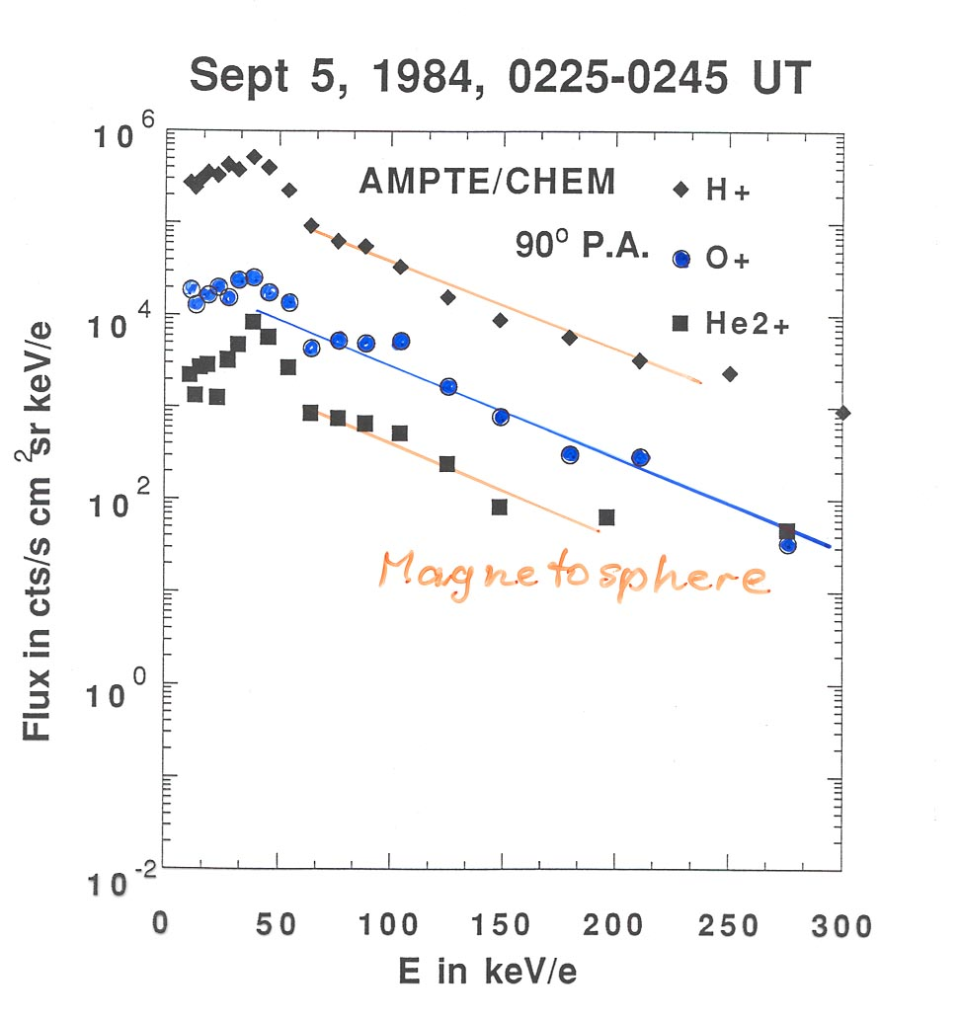
As we can see, the spectra in the magnetosphere, as shown for time Sept 5, 1984, 225-245 UT, are only similar to the ones in the upstream region for oxygen. In the other cases the spectra upstream are much steeper. If the source were in the magnetosphere, the low energy particles would leak out more easily, while the higher energies are suppressed. As we will see later this is opposite to the behavior of the spectra as we go farther and farther away from the shock. That not all of the magnetospheric ions make it upstream, is shown by the oxygen the fluxes are lower by 3 orders of magnitude.
However, one event may not be enough to make the point. We have studied this for a number of events. The show the same behavior. While O⁺ always shows about the same spectral slope upstream as in the magnetosphere, the slopes of H⁺ and He²⁺ are always steeper.
This is reemphasized with the ratio of the spectral indices for the upstream particles and the magnetosphere.
While we are at the job, we can compare the composition of the upstream particles with the solar wind and with the magnetosphere. The composition should reflect that of the source.
Solar Wind: H⁺, He²⁺, C, O^{≈6+}
Magnetosphere: H⁺, He²⁺, C, O^{≈6+} + O⁺ !
Therefore, we have an excellent tracer. If we form the ratios of the abundances, they should be similar for all species, if the source and the energetic particle population are coupled. If the ratio for one species wonders around, while the others are constant, as we see in the next figure, we have to deal with more than one source!
Doing this for a number of events we find that the abundance of O⁺ is always much lower upstream than in the magnetosphere and varies greatly, whereas the abundance of He²⁺ correlates. This is not too surprising because H⁺ and He²⁺ in the magnetosphere also come from the SW. This tells us, how careful we have to be with such analyses.

Let us look one more time at the different spectra and the composition variation.
Could these variations be transport effects? If we have a source, we establish a gradient, and thus particles leak diffusively down the gradient. As we can draw from our transport equations, a density gradient is established as a balance between convection and diffusion. If we can invoke near isotropy of the distribution in a wide energy range, we may simplify the general diffusion convection equation for a distribution function by:
$V_{\text{sw}}Ñf−Ñ(k_{||}Ñf)$ = 0 (V.3_11)
Let us assume diffusion only ||B, because diffusion perpendicular to B is much weaker. The diffusive flux away from the shock is now balanced by convection with the solar wind towards the shock. It follows $k_{||}=V_{\text{sw}}·L$
if we further assume that L is the typical scale length, i.e. $\frac{1}{L}»Ñ$
If upstream particles were from the magnetosphere, we have to explain why they show a steeper spectrum. This means the flux at high energies (for H and He) is reduced more than at low energies. This means a steeper gradient (i.e. a shorter L) for high energies. Let us compare this with observations
Let us concentrate for this exercise on the quasi-parallel shock. Here we see an almost isotropic, i.e. diffusive distribution. Thus we can assume that diffusion and convection play the roles as discussed above. Let us now further restrict this study on cases when the magnetic field was radial, i.e. we are at the nose of the bow shock and B is parallel to V_{sw}, the simplest case for the shock (no VxB field!).
If we now plot the flux of these particles as function of the distance from the shock, we see that there is indeed a spatial gradient, as expected.
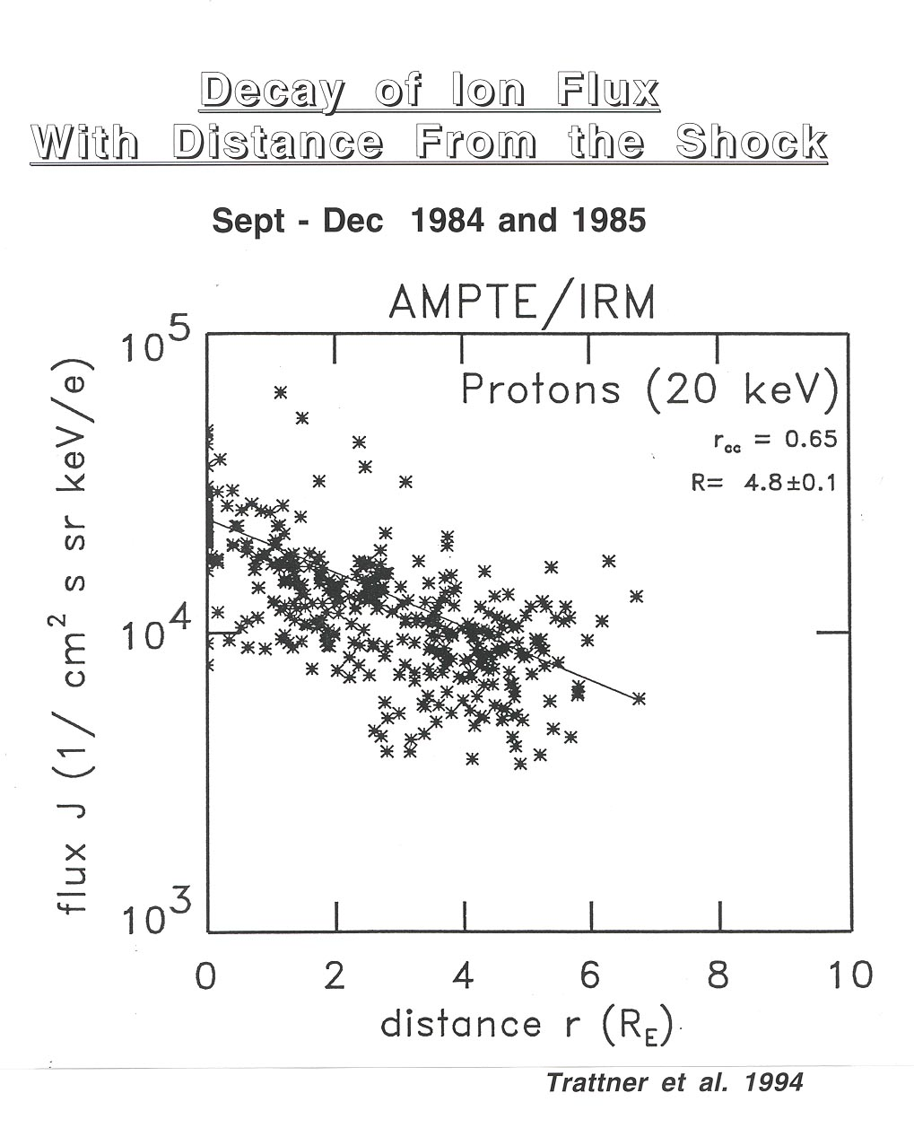
However, doing the same for different energies shows that the behavior is opposite to what would be compatible with leakage. The gradient is weaker for higher energies, i.e. high energies would leak more easily.
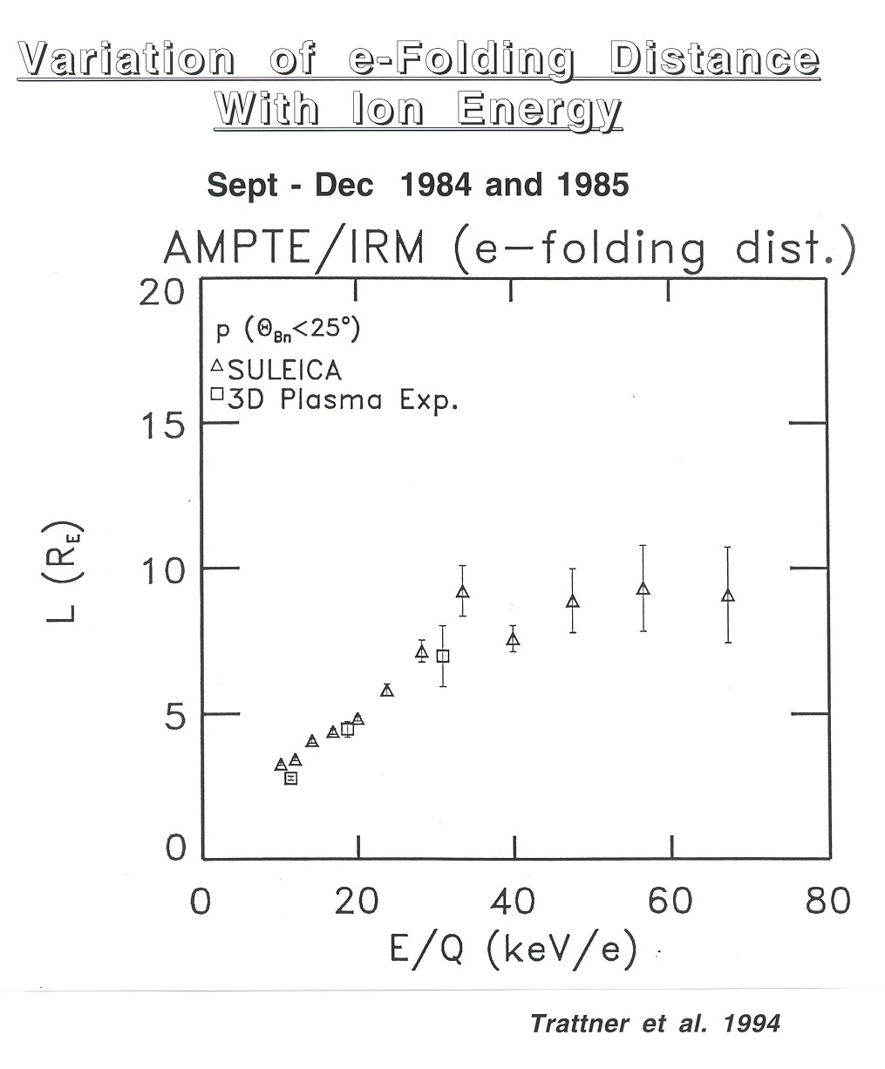
If we think of our oxygen, this makes sense, since both higher energy particles and oxygen (heavier!) have larger gyroradii than protons (larger rigidity).
Summary: There are some energetic ions from the magnetosphere (the oxygen), but the majority of ions are generated at the bow shock. This view is emphasized by the fact that
a) solar wind density and energetic particle density are correlated
b) the spectral index of the particles scales with the solar wind speed, which can be seen as the energizer of the acceleration processes.
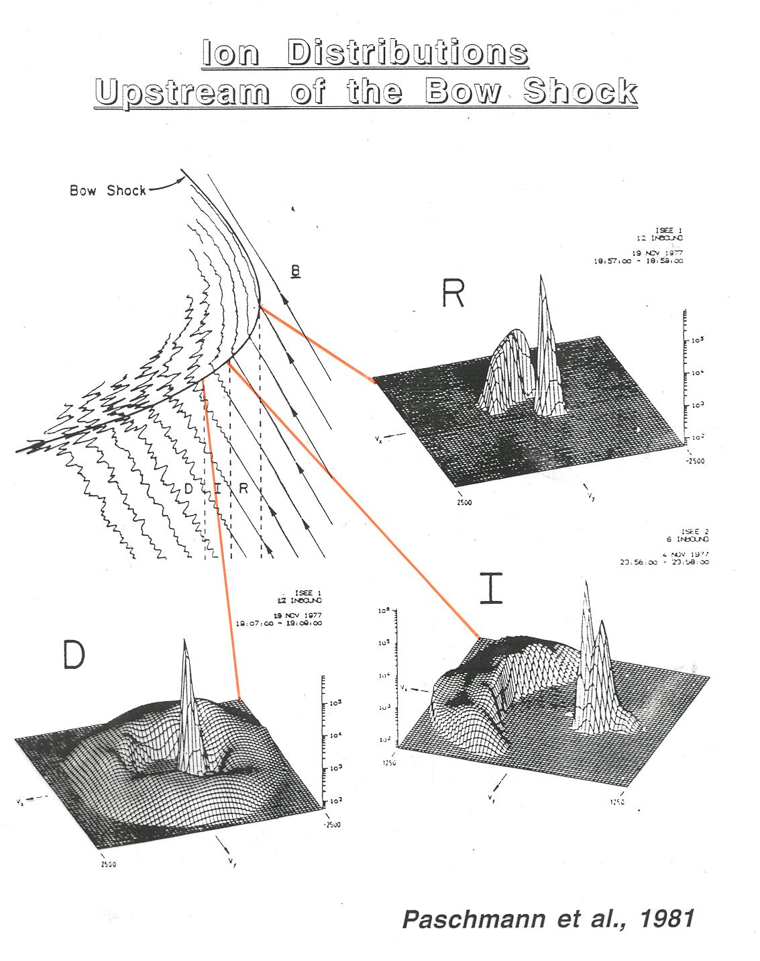
Even, if we settle for the particles that get accelerated at the shock, we find different populations, depending on where we observe them, as obvious from the following figure.
We find
- beams at the quasi-perpendicular shock and
- diffuse ions at the quasi-parallel shock
indicating two different processes.
Let us start with the beams and associated ions at the quasi-perpendicular shock

